Sudoku Program

Name: al rony Student ID: 91815855E103

I started the implementing the program by including my libraries: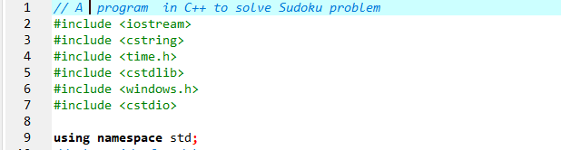

Then I went on to make the grid of my Sudoku and also declaring the functions: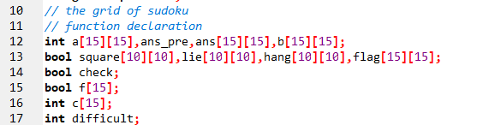

Also, I added Colors for the graphical display of the Sudoku:

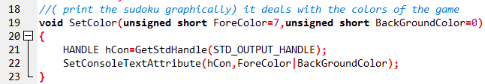

A driver Program was Created to test the above functions:

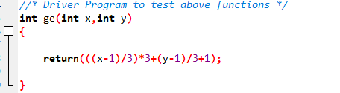

Long code was implemented for the Display of the Sudoku:

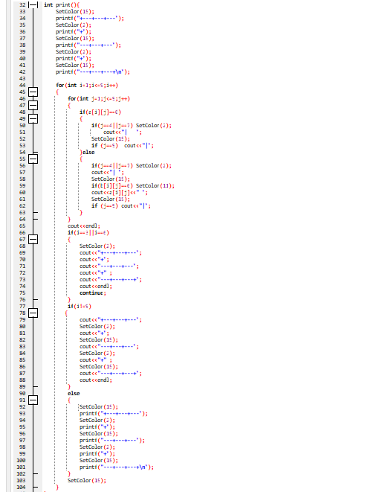

Like Display code one was also implemented for the answer grid:

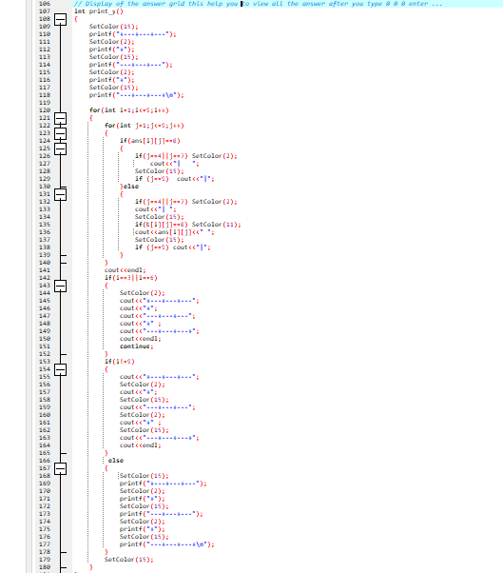

Implementation of the algorithms began:

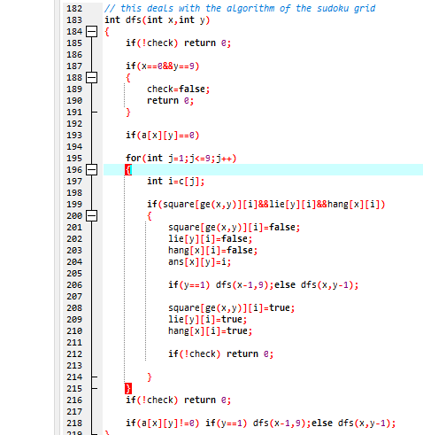

I also created a function to aid my arithmetic grid:

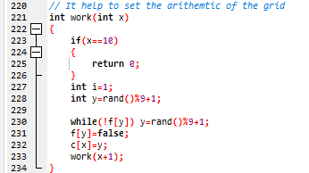

A utility function to print grid was made to initialize the Sudoku grid:

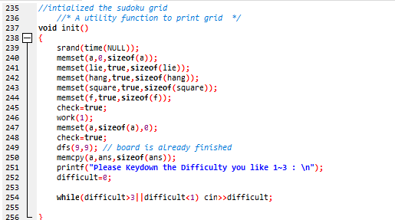

A function to check whether the grid is filled or not was shown below:

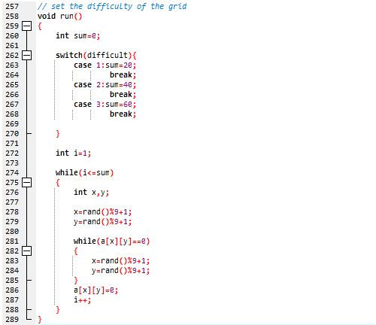

In addition with the code that was written before I also created one to know verify if the players answer was same as the actual solution:

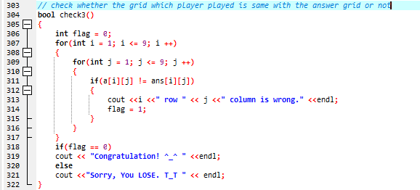

The Main Function:

